LESSON 4: HOW TO REPLACE THE COLOR OF AN OBJECT IN PIXLR

Getting Started
1) Open Pixlr Advance

2) Open an image that you want to change the color from your Computer or URL:
http://3.bp.blogspot.com/-HNlduHp-pa4/UIv87cszi5I/AAAAAAAAFHI/_vQNEuo8xhA/s1600/chevrolet-camaro-production-2010-yellow-nose.jpg

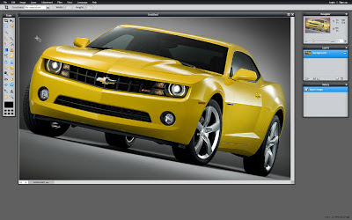

Selecting the Parts You Want to Keep
1) Click Ctrl + A to surround all the image.

2) Then, click on the Lasso Tool (L) and by pressing CTRL button all the time surround the colors you want to keep and similar with your original color. For example; I am going to change the yellow, but there are few points I want to keep like Chevrolet emblem.

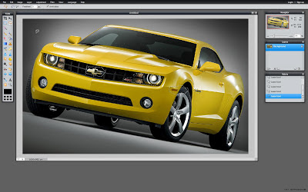

Color Replacement

1) I selected the parts I wanted to keep. Then click the Color Replacement Tool which is in the Tool Menu on the left side of the screen. (Look at Lesson 1)

2) Choose the color you want to do from the Color Selector at the bottom of the Tool Menu. (Look at Lesson 2)

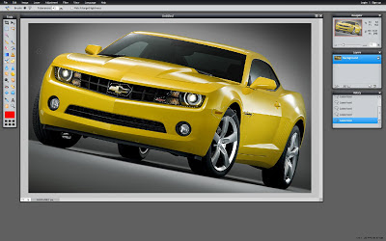

3) Set the Brush Size at the top of the site in the gray stripe. (Look at Lesson 3) Then Start to replace the Color :)

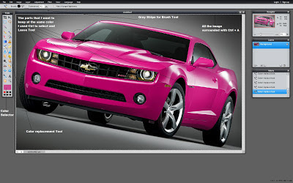

4) To get rid of the lines from Lasso Tool go to the Edit Menu, then Click Deselect All (Ctrl + D)

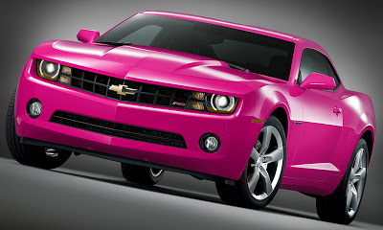

Find a photo on the internet and practice what you learned

LESSON 6: HOW TO DESATURATE (BLACK AND WHITE) A PICTURE WHILE AN OBJECT IS STILL COLORFUL

Getting Started
1) Open Pixlr Advanced

2) Browse the image that you want to desaturated from you computer or an URL:
http://resources1.news.com.au/images/2011/12/29/1226232/712937-child-gardening.jpg

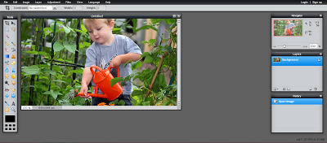

Surround the Part that you Want to Keep Colorful
This is an optional part because you do not want to keep a colorful part in you image, it is quite cool effect. You apply it on daily photos too. For example, cell phones and bags are very popular items for this technique.

1) Click on the Lasso Tool (L) icon on the tool bar.

2) Press Ctrl + A to select all the image.
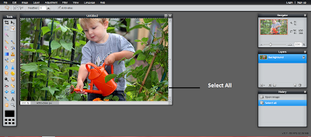

3) Use the Lasso tool (L) to surround the part/object that you want to keep colorful. There are 2 types of Lasso Tool (L) that you can find in the gray stripe on the top of website; Freehand Lasso Tool and Polygonal Lasso Tool. I am going to use the Polygonal Lasso Tool, because it is more accurate than Freehand Lasso Tool. You can zoom in the object while using the Lasso Tool. Lastly, because you selected the whole image, you must use the CTRL button while using the Lasso Tool (L).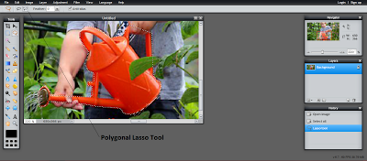

Desaturate the Image and Missing Parts
1) Go to the Adjustment Menu in the black stripe and click to Desaturate.
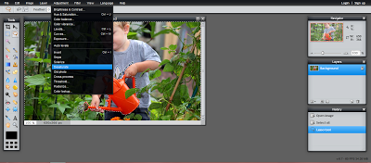

2) There will be not desaturated parts like the leaf and finger. You have use the Lasso Tool (L) again to select the fingers and leaf. There is no need to select all the image right now, so that must use Shift button while selecting more than one item.
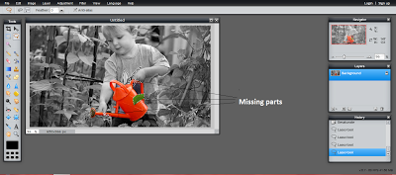

3) After Choosing the undesaturated parts in the image by Lasso Tool (L), go to the Adjustment Menu and Click to Desaturate Button.
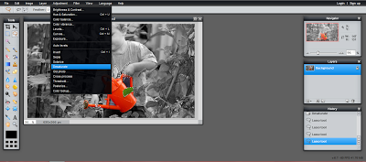

4) Lastly, to get rid of the lines in the image, go to the Edit Menu and Click to Deselect All (Ctrl + D)
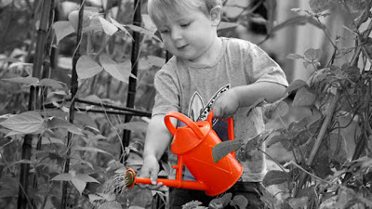

Find a photo on the internet and practice what you learned

LESSON 12: HOW TO REMOVE AN OBJECT IN PIXLR

Getting Started
1) Open Pixlr Advanced

2) Open an image that you want to remove an object on it,
http://lh6.ggpht.com/_LXgkZ-yKhEs/TIk-EbqDaSI/AAAAAAAABu0/qdUrrbsLMnA/off-road-Evoque.jpg

Brush Adjustments
1) Select Clone Stamp Tool(s) from the tools menu on the left side of the screen.
2) Then adjust your brush size on the top of the screen according to object. I will go with 30.
3)After that, adjust the opacity. I recommend you to use a value between 90 and 100. I will go with 95.
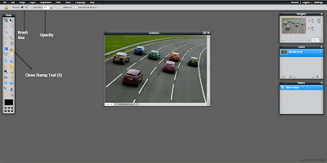
Note: If you have trouble about finding tools, this may help ;
Basics of Pixlr

Removing the object
1) We have to take a sample pattern to apply it on the object.
The Clone Stamp Tool is change the pattern as selected before.
In our example, I want to remove the pink car so that I have to choose the road pattern.

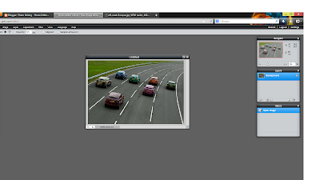

2) Press "Ctrl" to select the pattern.

3) You have be very careful while using this tool because. It does not stay stable while removing the object. The point the you choose will change according to your mouse movements.

4) By clicking the left button of mouse remove the object.
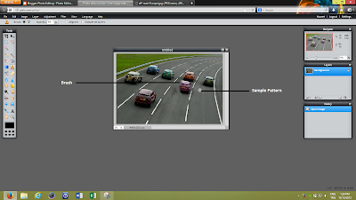

Tricks
1) Move your brush in the same direction all the time. Otherwise, it will look like blurred.
2) If you are not satisfied with your sample pattern, you can always change it.
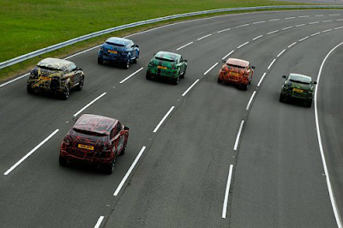
Find a photo on the internet and practice what you learned

