Name_________________________________________ Date_________________________ Period______
The American People: Graph Skills
As John F. Kennedy said, America is “not merely a nation but a nation of nations.” All Americans are descended from immigrants or are immigrants themselves. (Migration can either be forced or voluntary, so even those descended from slaves or refugees are descended from immigrants).
Minority Majority: the projected situation in which the non-Hispanic white will represent the minority of the U.S. population and minority groups combined will represent the majority.
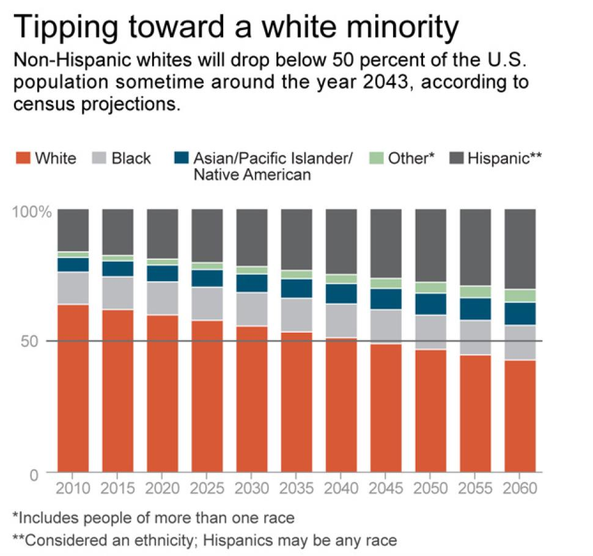
- What is the largest minority group and what trend do you see?
- What is the second largest minority group and what trends and patterns do you observe?
- What 2 U.S. trends do you think will have to continue in order for these projected increases to happen and what factors are contributing to these patterns?
Use census data for the following questions; here is the link: http://datamapper.geo.census.gov/map.html
- What states use the map and tell me which states have large proportion of white, black, and Hispanic population?
- What U.S. States already have a minority majority?

