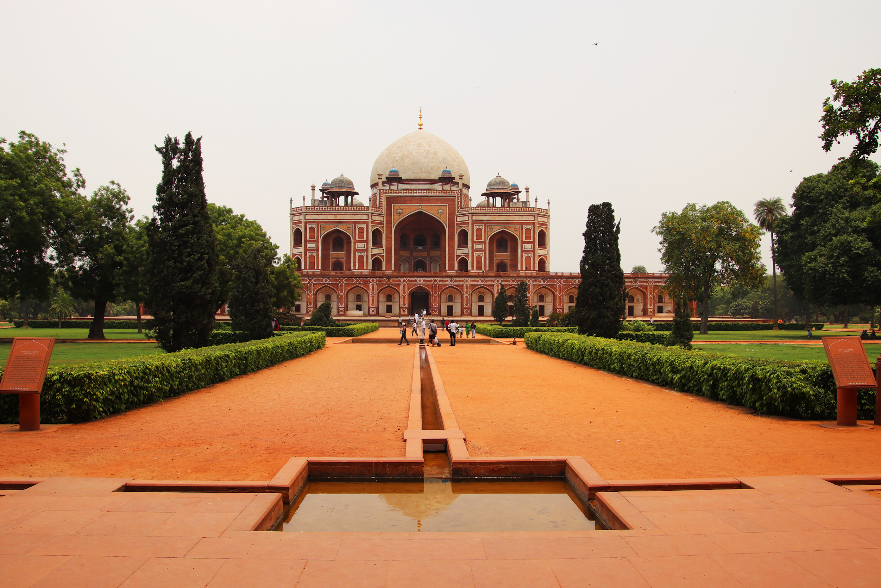
Project Scenario:
Personal photos for your social media timeline or travel photos often need a little tweaking to get that feeling that you experienced while you were there. We start with an introduction to the Photoshop Interface and critical settings, and then move on to cropping images, removing distracting elements, perfecting colors, and importing and exporting common file types from Photoshop.

Project Goal:
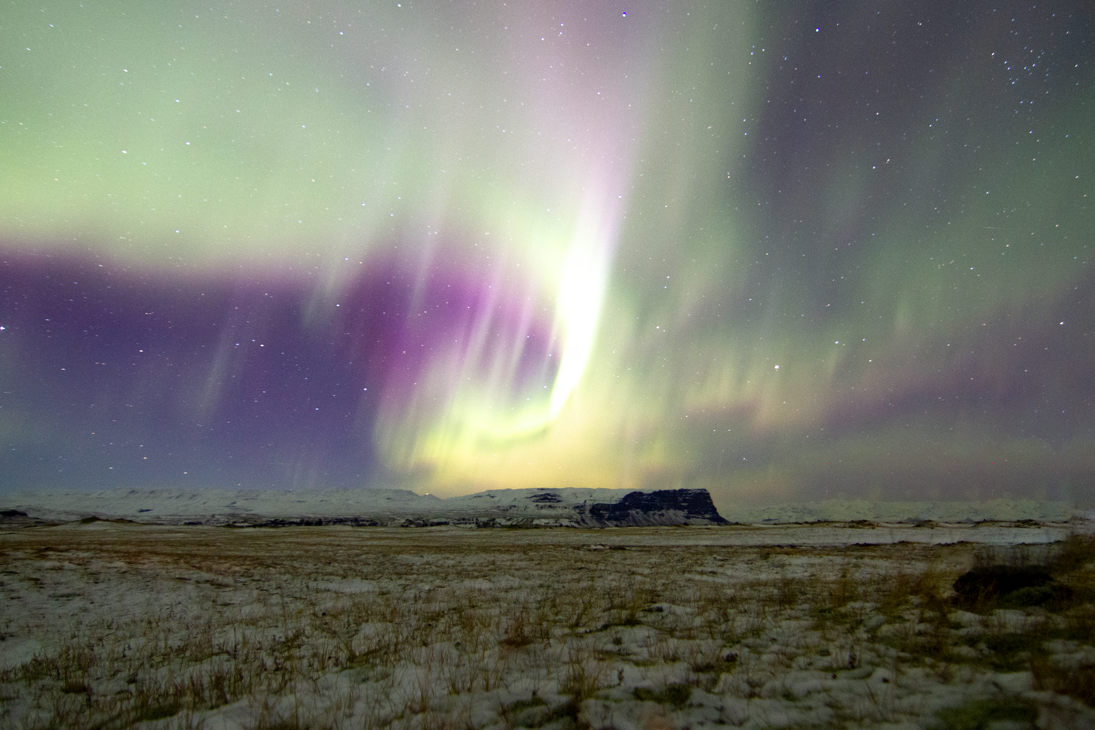
Fix common problems in Photos.

Project Timeline:
This may take a student 5-6 hours of class time to complete.

Video | Title | Length
TOPIC 1.00 | Meet Photoshop | 6:12
TOPIC 1.01 | Setting Preferences | 5:38
TOPIC 1.02 | The Learn Panel | 4:23
TOPIC 1.03 | Arranging the Interface | 5:20
TOPIC 1.04 | Save and Reset Photoshop Workspaces | 4:26
TOPIC 1.05 | Crop and Straighten Images | 4:39
TOPIC 1.06 | Spot, Heal, and Clone Stamp | 4:56
TOPIC 1.07 | Adjustment Layers | 6:39
TOPIC 1.08 | Save and Export | 5:36
TOPIC 1.09 | Browsing with Bridge | 5:31
TOPIC 1.10 | Developing RAW Images | 3:24
TOPIC 1.11 | Perfecting Aurora | 3:09
TOPIC 1.12 | Project 1 Review | 8:25
TOTAL |  | 68:18

Project Outline:
- Watch and follow along with BrainBuffet’s Photoshop Project 1 “Simple Photo Fixes”
- Complete the GAMER Mission Handbook with information from the videos
- Follow along as Rob explores the Photoshop preferences and workspace.
- Use the Clone Stamp to remove distracting people from the backgrounds of the image.
- Use the Crop tool and straighten the horizon.
- Open the Camera Raw editor and learn how to create manual adjustments to your images

PROJECT 1 SPECIFICATIONS
Red Fort Photo PSD:  Be straightened.  People removed with spot healing brush.  Metadata has Copyright & Contact Info  PSD Layers:  Modified Brightness/Contrast Adjustment Layer  Modified Hue/Saturation Adjustment Layer  Aurura.jpg Photo:  Horizon straightened  People have been removed using content aware fill | Completed folder should have:  Aurora PNG  RedFort PNG  RedFort PSD  RedFort@0,1x  RedFort@0,25x  Student should be able to:  Save or reset workspace  Change the metadata and add keywords  Open an image in Photoshop  Save an image as a Photoshop Document (PSD)  Quick export an image  Adjust width of panel, move panels around within workspace

Adobe Certified Professional 2021 Exam Objectives Covered:

2.2 Navigate, organize, and customize the application workspace.

a Identify and manipulate elements of the Photoshop interface.

b Organize and customize the workspace.

c Configure application preferences.

2.4 Import assets into a project.

a Open or import images from various devices.

b Place assets in a Photoshop document.

c Use the Adobe Camera Raw interface to process images.

2.5 Manage colors, swatches, and gradients.

a Set the active foreground and background color.

3.3 Understand the difference between destructive and nondestructive editing.

a Nondestructive editing: Smart Objects, Smart Filters, and adjustment layers.

4.1 Use core tools and features to create visual elements.

a Create and edit raster images.

4.5 Use basic reconstructing and retouching techniques to manipulate digital graphics and media.

a Apply basic auto-correction methods and tools.

b Use various tools to repair and reconstruct images.

c Evaluate or adjust the appearance of objects, selections, or layers using various tools.

d Use Photoshop tools to manage exposure and saturation.

5.2 Export or save digital images to various file formats.

a. Save in the native file format for Photoshop (.psd).

b. Save in appropriate image formats for print or screen.

c Export project elements.

Materials/Equipment:

Computer meeting the Minimum Specs for Photoshop

A copy of Adobe Photoshop

Internet Connection for resources

Resources/References:

BrainBuffet’s Photoshop Course for Project 1

Source files for course (Optional: Enrichment Files)

GAMER Mission Handbook

Concise Help, Explanation, and Tips (CHEaTs)

Make sure you understand the workspace and how to customize it for your own personal workflow.

Some tools are hidden in the toolbar. Learn where they all live!

Understand how to work with RAW images

Learn to browse with Bridge, it’s an incredible tool

Extension Challenges:

Complete BrainBuffet Photoshop Project “Facebook Tweaks”

Restore some of the extra images in the downloads folder for this project.

Try a Photoshop tutorial you find online

Find photos online and fix them yourself

Cross-Curricular Enrichment:

Language Arts: Complete an interview with a family member about a trip they took that changed their perspective on life. Write a report on the lives of the people in your pictures and the events shown.

Language Arts: Compose a fictional account of the people in your pictures and the events shown.

Math- Write a formula that calculates final image size based on pixel size and resolution

Social Studies- Find an image from a famous historical event and restore it, then write a brief reflection on the importance of that event.

Science/Technology- Research how images are created or shared- there are many ways!! Printing, Film, Digital cameras, projection (digital and film,)

Science/Technology- Make your own film camera. Yes, seriously- (https://www.diyphotography.net/23-pinhole-cameras-that-you-can-build-at-home/)

Evaluation:
Did you meet every one of the project specifications? Can you customize the Photoshop Interface? Can you import and tweak photos? Can you process RAW images? Do the images look realistic? Are the colors natural looking?
PROJECT 1 SCORING RUBRIC |  |  |  |  | Student Score
Mastery of Skills | 10 points:  Student can demonstrate abilities according to specifications. (Screenshots of progress recommended or extra images have been completed to show mastery in skills). | 7 points:  Only the required images are completed without screenshots or extra images to demonstrate a mastery of skills according to specs. |  | 1 point:  For each image completed, add a single point.
Effort Level | 10 points:  Photographs are carefully corrected as shown in the tutorials. Finished images have natural looking colors and retouching is invisible. | 7 points:  Tutorial instructions have been followed, but finished images have noticeable retouching or unnatural looking colors. |  | 4 points:  Tutorial instructions were not followed completely.
Requirements Completed | 5 points:  Files are properly saved in multiple formats for web and digital storage. |  | 2 points:  Files are saved only as one format or saved incorrectly.
Total Points Earned
(25 points possible)

