NAME:

Although it was the assassination of the Austrian archduke, Franz Ferdinand that led to the outbreak of world war one in August 1914, the actual causes of the war were more complicated.

Alliances
An alliance is an agreement made between two or more countries to give each other help if it is needed. When an alliance is signed, those countries become known as Allies. A number of alliances had been signed by countries between the years 1879 and 1914. These were important because they meant that some countries had no option but to declare war if one of their allies declared war first.

1879  The Dual Alliance  Germany and Austria- Hungary made an alliance to protect themselves from Russia | 1881  Austro-Serbian Alliance  Austria-Hungary made an alliance with Serbia to stop Russia gaining control of Serbia | 1882  The Triple Alliance  Germany and Austria- Hungary made an alliance with Italy to stop Italy from taking sides with Russia
1914 |  | 1894
Triple Entente (no |  | Franco-Russian
separate peace) |  | Alliance
Britain, Russia and |  | Russia formed an
France agreed not to sign |  | alliance with France to
for peace separately. |  | protect herself against
 |  | Germany and Austria-
 |  | Hungary
1907 | 1907 | 1904
Triple Entente | Anglo-Russian Entente | Entente Cordiale
This was made between | This was an agreement | This was an agreement,
Russia, France and | between Britain and | but not a formal alliance,
Britain to counter the | Russia | between France and
increasing threat from |  | Britain.
Germany.

Imperialism
Imperialism is when a country takes over new lands or countries and makes them subject to their rule. By 1900 the British Empire extended over five continents and France had control of large areas of Africa.

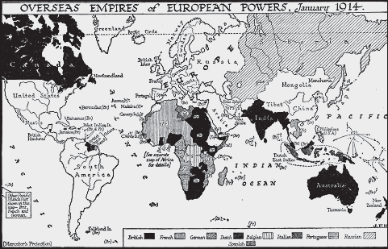

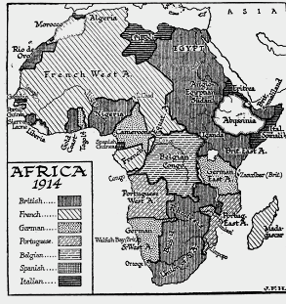The amount of lands 'owned' by Britain and France increased the rivalry with Germany who had entered the scramble to acquire colonies late and only had small areas of Africa.

France had recently been given Morocco by the British. Morocco’s bid for independence was supported by Germany

Militarism
Militarism means that the army and military forces are given a high profile by the government.

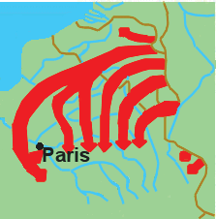The growing European divide had led to an arms race between the main countries. The armies of both France and Germany had more than doubled between 1870 and 1914 and there was fierce competition between Britain and Germany for mastery of the seas. The British had introduced the 'Dreadnought', an effective battleship, in 1906. The Germans soon followed suit introducing their own battleships. The German, Von Schlieffen also drew up a plan of action that involved attacking France through Belgium if Russia made an attack on Germany.

Schlieffen’s plan to attack Paris through Belgium

Nationalism

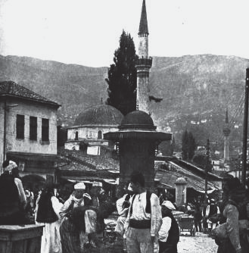Nationalism means being a strong supporter of the rights and interests of one's country. The Congress of Vienna, held after the Napoleonic wars left both Germany and Italy as divided states. It was nationalism the re- unification of Italy in 1861 and Germany in 1871. France was angry because the settlement at the end of the Franco-Prussian war had given Alsace-Lorraine to Germany. Large areas of both Austria-Hungary and Serbia were home to differing nationalist groups, all of whom wanted freedom from the states in which they lived.

There were strong nationalist groups in Bosnia

Crises

The Moroccan Crisis

In 1904 Morocco had been given to France by Britain, but the Moroccans wanted independence and were supported by Germany. War was avoided, but in 1911, the Germans were again protesting against French possession of Morocco. Britain supported France and Germany was persuaded to back down for part of French Congo.

The Bosnian Crisis

In 1908, Austria-Hungary took over Bosnia. This angered Serbians who felt the province should be theirs. Serbia threatened Austria-Hungary with war, Russia, allied to Serbia, mobilised its forces. Germany, allied to Austria-Hungary mobilised its forces and prepared to threaten Russia. War was avoided when Russia backed down. In 1911 and 1912 there was war in the Balkans when the Balkan states drove Turkey out of the area. The states then fought each other over which area should belong to which state. Austria-Hungary intervened and forced Serbia to give up land. Tension between Serbia and Austria-Hungary was high.

Causes of WW1
- What is meant by the term alliance?

- Which countries were allied by the Triple Alliance?

- Which countries were allied by the Triple Entente?

- Why was Germany annoyed by Imperialism?

- Which armies had increased in size between 1870 and 1914?

- Describe the Schlieffen Plan.

- Why were the two crises important factors?
- Which countries were bound to each other by which alliance?

- How did imperialism contribute towards Germany’s increasing anger with Britain and France?

- Why was nationalism an important factor?

- Describe the part played by Germany in increasing European militarism.

- What links were there between the two crises and:
  - Alliances
  - Imperialism
  - Militarism
  - Nationalism

