**America in World War WWII**

Throughout this era, the world will see the rise of three powerful nations led by brutal dictators in Germany, Italy, and Spain and how their aggressive policies led to the outbreak of another major conflict in Europe and Asia. Despite efforts by the U.S. to remain isolated, events at Pearl Harbor, Hawaii will lead to the U.S. entering WWII. Despite the war only lasting 5 year, the world will be in more danger because of the development of the nuclear weapon, pushing us into conflict with the Soviet Union

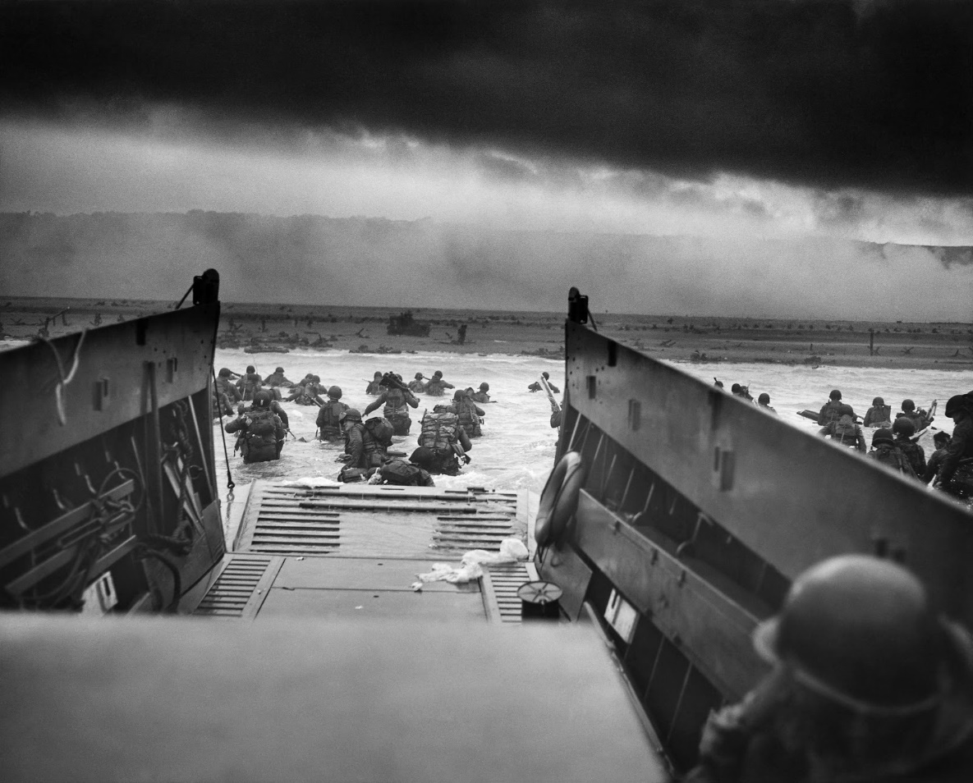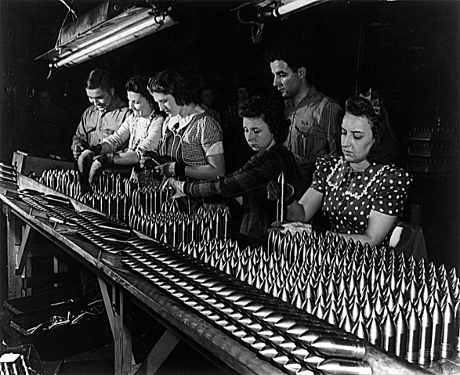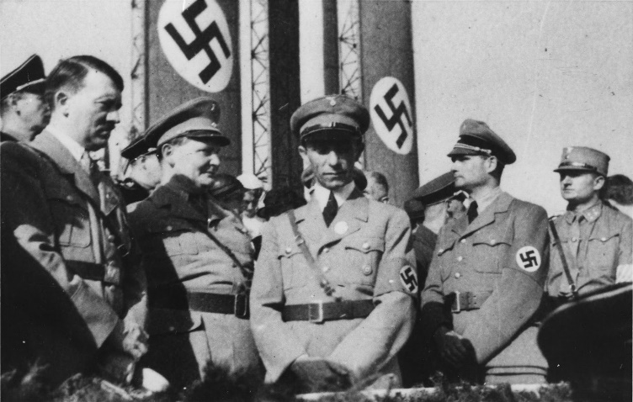

After World War I, Why did the United State returned to its traditional policy of isolation?

|  |  |  |
| --- | --- | --- |
| Name of Dictator | Country | How did they become dictators in their country? |
| http://i.dailymail.co.uk/i/pix/2016/08/31/15/37C16BF700000578-3767201-image-a-60_1472653614419.jpg  ______________________ |  |  |
| https://media1.britannica.com/eb-media/58/129958-004-C9B8B89D.jpg  _______________________ |  |  |
| https://ichef.bbci.co.uk/news/624/cpsprodpb/C18B/production/_87974594_32be803c-efcf-47ef-9a17-197106074016.jpg  ______________________ |  |  |

|  |  |
| --- | --- |
| How did the following lead to the start of WWII? | |
| What is the League of Nations? |  |
| Hitler Appeasement |  |
| Invasion of Poland |  |

Describe Germany military strategy, Blitzkrieg.

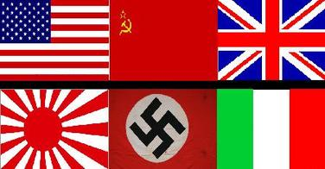

Place the countries that participated in WWI in their correct allegiance

|  |  |
| --- | --- |
| ALLIES | AXIS |
| 1.  2.  3.  4. | 1.  2.  3. |

**America Enters the War**

|  |  |  |
| --- | --- | --- |
| **Name of the U.S. Policy** | **Define** | **Does it push America towards join the war or increase her neutrality? Explain!** |
| Neutrality Act |  |  |
| Cash-and-Carry |  |  |
| Flying Tigers |  |  |
| Lend Lease Act |  |  |
| Atlantic Charter |  |  |

Read the following excerpt:

Yesterday, December 7, 1941 - a date which will live in infamy - the United States of America was suddenly and deliberately attacked by naval and air forces of the Empire of Japan. The United States was at peace with that nation and, at the solicitation of Japan, was still in conversation with its Government and its Emperor looking toward the maintenance of peace in the Pacific…

I ask that the Congress declare that since the unprovoked and dastardly attack by Japan on Sunday, December seventh, 1941, a state of war has existed between the United States and the Japanese Empire.

-President Franklin D. Roosevelt, December 8th, 1941.

1. What event was President Franklin D. Roosevelt describing in his famous “A Date Which Will Live in Infamy” Speech?

2. What is the response by the U.S. Government after Pearl Harbor is attacked?

Analyze the following WWII and describe how Americans are assisting in the war effort on the Homefront

|  |  |
| --- | --- |
| America at War: The Homefront | |
|  | https://s-media-cache-ak0.pinimg.com/736x/62/f7/ec/62f7eccabcfdede8bf606481653906d4.jpg |
| http://www.livinghistoryfarm.org/farminginthe40s/media/crops_0201.jpg |  |
|  | https://upload.wikimedia.org/wikipedia/commons/1/12/We_Can_Do_It%21.jpg |
| Image result for wwii rationing |  |

How did the following minority groups participate in WWII?

|  |
| --- |
| African Americans: |
|  |
| Native American/ Navajo Code Talkers |
|  |
| Mexican Americans |
|  |
| Japanese/Executive Order 9066 |
|  |

|  |  |  |  |  |  |  |  |  |
| --- | --- | --- | --- | --- | --- | --- | --- | --- |
| Describe the Following Turning Point During WWII: European and Pacific Theatres   |  |  | | --- | --- | | D-Day | Battle of the Bulge | |  |  | | ­Battle of Midway | | |  | | |



1. What WWII event follows the Newspaper headline above?

Island Hoping

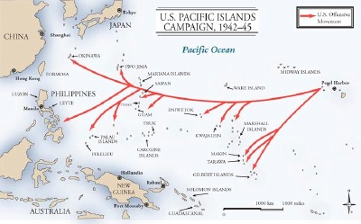

1. What strategy is the U.S. military using during the Pacific Theatre of WWII? Describe the strategy and its ultimate goal during the war.

|  |  |  |  |  |
| --- | --- | --- | --- | --- |
| What are the Pros and Cons of using the Atomic Bomb on  Hiroshima and Nagasaki.   |  |  | | --- | --- | | Pros | Cons | | 1.  2.  3.  ` | 1.  2.  3. | |

1. What were the Nuremberg trials and how does it connect to the Holocaust?

Identify the following U.S. WWII historical Figures

|  |  |
| --- | --- |
| Vernon Baker |  |
| Dwight Eisenhower |  |
| Omar Bradly |  |
| George Patton |  |
| Chester Nimitz |  |
| Douglas MacArthur |  |
| George C. Marshall |  |
| President Harry S. Truman |  |

**COLD WAR**

Following World War II, the United States and the Soviet Union entered a 45 year period of tension between the two countries known as the Cold War. The failure of the Soviet Union to allow free elections in Eastern Europe (following the end of WWII) and the establishment of communist countries prompted the United States to engage in a policy of containment.

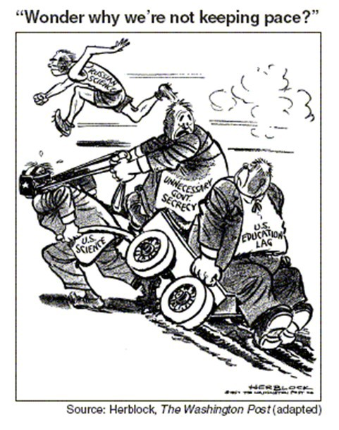

**What event occurred in 1957 and how is it associated with the above cartoon?**

1. Describe the U.S. responses to Soviet aggression after World War II:

|  |  |
| --- | --- |
|  | Identify the responses below |
| Truman Doctrine |  |
| Marshall Plan |  |
| North Atlantic Treaty Organization (NATO) |  |
| Berlin Airlift |  |
| John F. Kennedy’s role in the Cuban Missile Crisis |  |

1. Why was the launching of Sputnik a significant event?
2. Why was the United Nations established and why would some be opposed to the U.S. par- ticipating in it?

4. What role did Eleanor Roosevelt play in the United Nations?

1. Identify each of the following and explain how they led to an increase in Cold War tensions?

|  |  |  |
| --- | --- | --- |
|  | Identify the event | Explanation of increase in tensions |
| Arms race |  |  |
| Space race |  |  |
| McCarthyism |  |  |
| House Un-American Activities Committee (HUAC) |  |  |

2. Explain U.S. involvement in the Korean War:

|  |  |
| --- | --- |
| Reasons for US Involvement in Korea | Outcomes of US Involvement in Korea |
|  |  |

1. How did defense spending impact economics from 1945 into the 1990s?
2. How did the Cold War impact education spending from 1945 into the 1990s?

3. How was the Korean War related to U.S. containment policy?

Identify the following terms and explain how they relate to the topic of the Cold War:

1. loyalty oaths
2. Venona Papers
3. Alger Hiss
4. Julius and Ethel Rosenberg
5. containment

**Vietnam and the 1960s**

The policy of containment and the domino theory would engage the United States in the Vietnam conflict. This war fought with widespread exposure through television would divide the United States. An anti-war movement would emerge and engulf the 1960s in a period of protest and change.

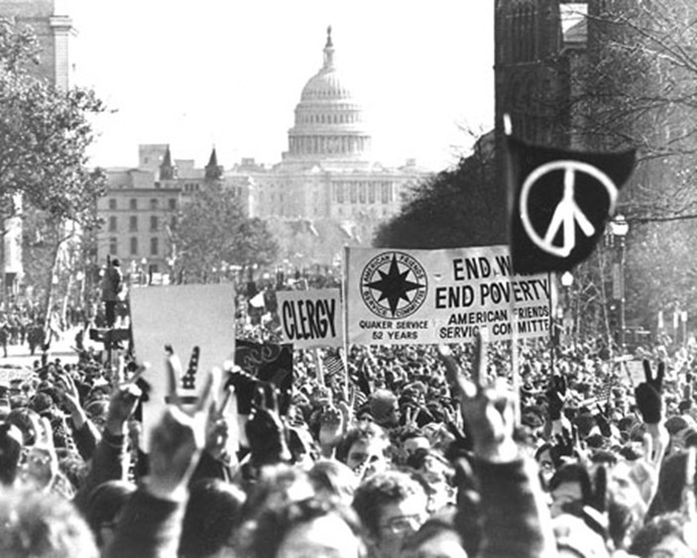

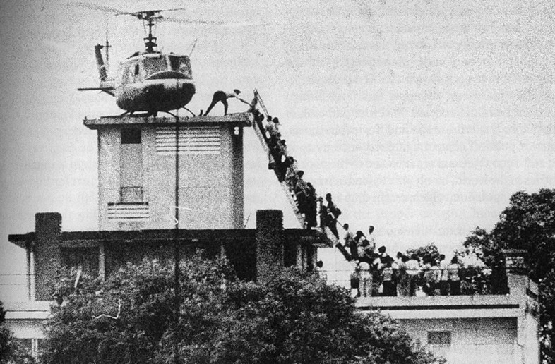

1. What is the domino theory? And how did it impact U.S. foreign policy?

2. Explain U.S. involvement in the Vietnam War.

|  |  |
| --- | --- |
| Reasons for US Involvement in Vietnam | Outcomes of US Involvement in Vietnam |
|  |  |

3. Identify the following major issues and events of the Vietnam War

|  |  |
| --- | --- |
| Tet Offensive |  |
| Escalation of forces  And troop build up |  |
| Vietnamization |  |
| Fall of Saigon |  |

1. Describe the following responses to the Vietnam War.

|  |  |
| --- | --- |
| Draft |  |
| **26th Amendment** |  |
| Role of the media |  |
| Credibility gap |  |
| Silent majority |  |
| Anti-war movement |  |

How did the following impact the relationship between the legislative and executive branches of government?

|  |  |  |
| --- | --- | --- |
|  | Define the event | How did this impact the relationship between the executive and legislative branches? Hint: Who had more power? Explain…. |
| Gulf of Tonkin Resolution |  |  |
| War Powers Act |  |  |

1. **Why did Roy Benavidez win the Congressional Medal of Honor?**
2. How did the events of the Vietnam War help to extend political rights for young people through the 26th amendment?
3. How did Americans participate in the democratic process (besides voting) during this time?

|  |  |  |
| --- | --- | --- |
|  | Description | Unintended Consequences |
| Great Society |  |  |
| Affirmative action |  |  |
| Title IX (9) |  |  |

1. How did the Supreme Court rule in ***Tinker v Des Moines*** and what were the effects of this case?
2. What was significant about the Miranda v Arizona case?

Identify the following as they relate to the Vietnam War:

1. Geneva Peace Agreement
2. Napalm

**Modern America 1970s-Present**

**The era from the 1970’s to the present, for our purposes, will be identified as Modern America. In this era, United States foreign policy shifts to more open relationships with communist China and the Soviet Union. As the Cold War ends our focus turns to combating terrorism. On the domestic front, this period ushers in a conservative movement to address the growth in federal power.**

1. Describe significant societal issues from the 1970s– 1990s in each of the following areas.

|  |  |
| --- | --- |
| Political Issues |  |
| Economic Issues |  |
| Social Issues |  |

1. What 3rd party was involved in the presidential election of 1992 and what impact did it have?
2. What was historically significant about the presidential election in 2008?
3. Explain the solvency of long-term entitlement programs such as Social Security and Medicare.

|  |  |  |  |
| --- | --- | --- | --- |
|  | Political | Economic | Social |
| Richard M. Nixon’s normalization of relations with China |  |  |  |
| Policy of détente |  |  |  |
| Reaganomics |  |  |  |
| Ronald Reagan’s “Peace Through Strength” |  |  |  |
| Support for Israel |  |  |  |
| Camp David Accords |  |  |  |
| Iran-Contra Affair |  |  |  |
| Marines in Lebanon |  |  |  |
| Iran Hostage Crisis |  |  |  |

|  |  |  |  |
| --- | --- | --- | --- |
|  | Political | Economic | Social |
| End of the Cold War |  |  |  |
| Persian Gulf War |  |  |  |
| Balkans Crisis |  |  |  |
| 9/11 |  |  |  |

|  |  |  |  |
| --- | --- | --- | --- |
|  | Political | Economic | Social |
| Conservative Resurgence of the 80s and 90s |  |  |  |
| Phyllis Schlafly |  |  |  |
| Contract with America |  |  |  |
| Heritage Foundation |  |  |  |
| Moral Majority |  |  |  |
| National Rifle Association (NRA) |  |  |  |