STAAR: World War II Picture Analysis Worksheet

WWII is one of the most important wars in world history. It was truly a global war and nearly every major country participated in the war in some way.
Directions: For the following activity, cut out the dates, captions, and pictures, and match each element to their corresponding date, caption or picture. Once your group has completed that, go through the timeline and answer the following questions.

- Before WWII started, Japan invaded northern China and this action angered the American government and people. In response to this, what role did America’s Flying Tiger play in this event? Besides China where else did Japan expand too before events leading up to the war?

- The Treaty of Versailles was supposed be an integral part to keeping peace in Europe and around the world, yet it was extremely weak and the League of nation which was chartered out of this treaty made several mistakes that led the rise of Hitler. When did Hitler take control of Germany’s Government, and what are some ways that the League of Nation failed to stop Hitler’s aggressive actions in Europe leading to WWII.

- Read the following excerpt and answer questions below:
“At 10:15 A.M. we heard the wailing of sirens! We noticed a heavy cloud of smoke billowing upward. It was obvious from the direction it was coming from that the Nazis had set the synagogue (Jewish Place of worship) [and stores] on fire. Very soon we saw smoke clouds rising up, mixed with sparks of fire. Later I noticed that some Jewish houses, close to the synagogue, had also been set alight under the expert guidance of the fire brigade. Its presence was a necessity, since the firemen had to save the homes of the non-Jewish neighborhood.”
Reminiscences by Yitzhak S. Herz, describing events in 1939 in

What event is being described in this primary source account and how does we use this description to describe later actions taken by Hitler during the war? How could this event been a sign for jew to flee German controlled areas?

- What event is a major turning point for Great Britain and France, what did Hitler do to provoke these nation into declaring war on Germany after Appeasement. Did Hitler show signs of expansionism ideal, if so what are some ways that he displayed them (What other countries did he invade)?

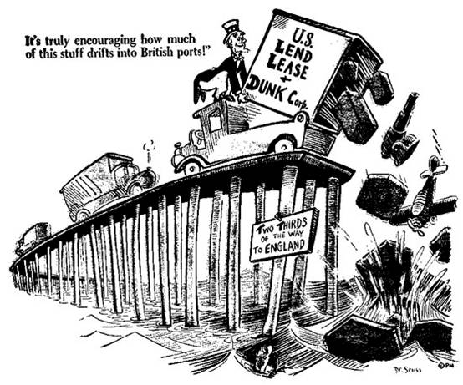
- For the first several years of the War, the U.S. was neutral and wanted to stay out of the affairs of belligerent (warring) nations. To prevent U.S. interactions, congress pass several Neutrality Acts to prevent U.S. involvement. Analyze the following cartoon and describe how the U.S. participated in assisting in the war despite its out spoken objection and attempt to maintain neutrality.

- What are ways that the U.S. government prepared for war, even though they were technically at peace?

- What event eventually broke U.S. neutrality, what nation was involved in the attack, and how did the U.S. respond? After the event, Japanese Naval Officer, Isoroku Yamamoto, said, "I fear all we have done is to awaken a sleeping giant (U.S) and fill him with a terrible resolve,” What did he mean by this?

- Now that the U.S. entered the war, what are examples on the home front that average American citizens contributed to U.S. victory, name at least three different methods.

- Women and minorities participated in the war, what are two ways women participate in U.S. Success in the war, and describe how African Americans and Native American were able to make an impact on in winning a “double victory,” a victory at home and in the war? How did a minority group lose their rights and what was the law that restricted their rights.
- What are some major turning point in the War in the Pacific? What is the most import battle that will lead to the U.S. and its allies in establishing a second front in the European Theatre? How was the Battle of the Bulge a sign that Germany was losing the war?

- What type of horrors did Soviet and American troops discover as they made their way to capture Germany and how was it an act of genocide? What did the international community do to the Germans that orchestrated these acts against humanity?

- What newly developed technology led to the Japanese surrender? Why Truman decide to kill thousands of Japanese innocent civilian instead of sending Troops to the island of Japan?

To submit your assignment
Email jstmary@houstonisd.org or Click on the following link

