Scenario | Correct Choices | Notes
1
2
3
4
WWI Highlights of the War: Simulation

Scenario | Correct Choices | Notes
7
6

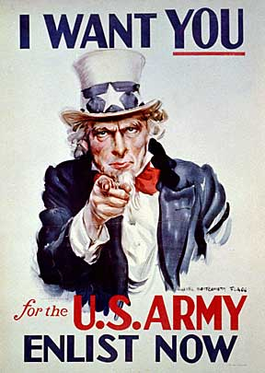
- During WWI, this was the most popular war poster in America. Why was this poster so important in recruiting young men to in enlist in the U.S. Army?

- In Schenck v. U.S., the Supreme Court ruled that freedom of speech can be limited under circumstances that create a “clear and present danger” to public safety. Why do you think Charles anti-war flyers create a clear and present danger to the war efforts?

  - Unmarried-no dependents under the age of 16
  - Not Employed in a essential industry that is crucial to the war efforts
  - Are both parent deceased and do you provide the sole income for your siblings
  - Are you a federal employee or clergy,
  - Are you medically disabled
  - Do you practice and morally unfit behaviors.
  - Sole household income?

